Entra ID Onboarding - SaaS Connector
Document Link: https://documentation.sailpoint.com/saas/help/ciem/azure/config_azure.html#registering-sailpoint-ciem-with-microsoft-entra-id

To onboard Entra ID application in SailPoint ISC, there are 3 steps is followed.
Use an Azure account with administrative privileges to:
- Register SailPoint CIEM (Cloud Infrastructure Entitlement Management.) as a new application with Microsoft Entra ID (formerly Azure AD).
- Grant permissions to read your Microsoft Entra ID policies and resource inventories.
- Create a client secret to use when registering your source with SailPoint CIEM.

Registering SailPoint CIEM with Microsoft Entra ID
You must first register SailPoint CIEM as an application with Microsoft Entra ID.
- Sign in to the Azure Cloud portal and select Microsoft Entra ID.
- Copy the tenant ID and save it somewhere accessible, as you'll need this information to connect the Azure cloud source to SailPoint CIEM.
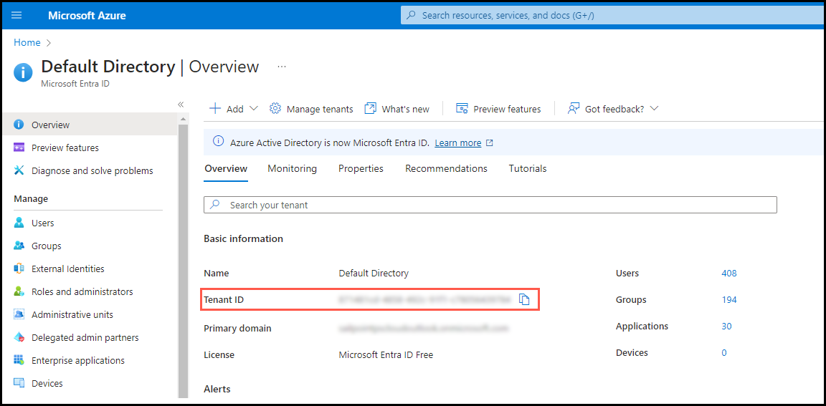
- Select App registrations in the left sidebar and select New registration.
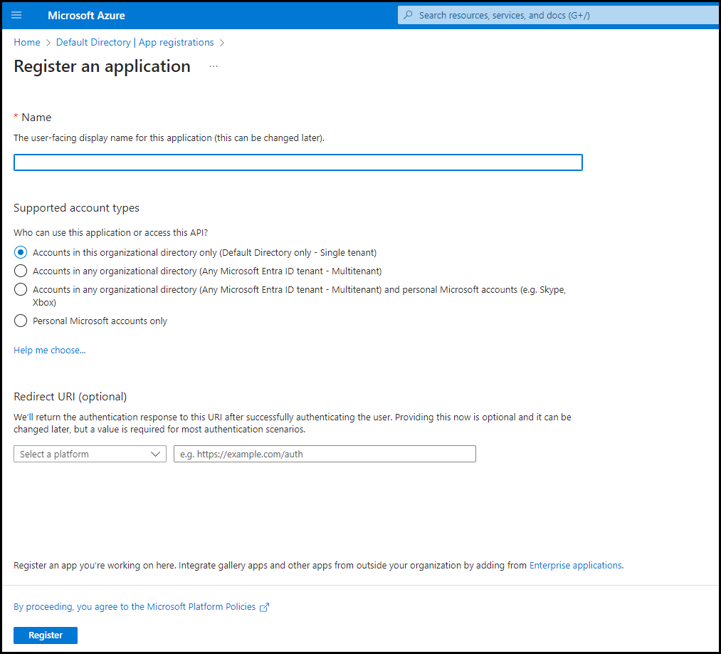
- Enter a name for the new application, such as "SailPoint CIEM".
- Under Supported account types, keep the default of allowing a single tenant to ensure that only accounts in the organizational directory can access this application.
- Select Register to register SailPoint CIEM with Microsoft Entra ID.
- Copy the Application (client) ID that's generated, as you'll need this information to connect the cloud source with SailPoint CIEM.

Granting Read Permissions to SailPoint CIEM
After you’ve registered SailPoint CIEM with Microsoft Entra ID, you must grant it the permissions required to read the security policies configured for the Azure source and the resources inventory.
Setting Up the Global Admin Role
- Select Properties in Microsoft Entra ID.
Entra ID Manage Properties.
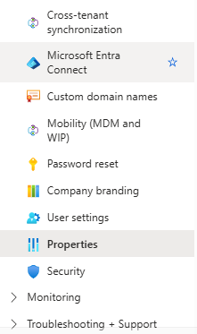
- Set the toggle for Access management for Azure resources to Yes.
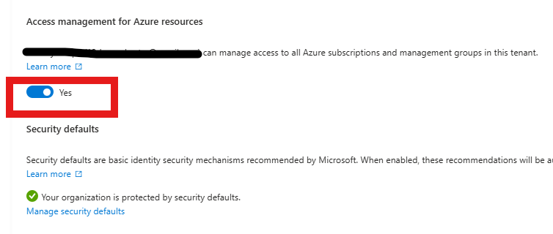
- Select Save.

Enabling Read Access to Microsoft Azure
You must enable the Directory.Read.All setting so that SailPoint CIEM can read the Microsoft Azure inventory.
- Select App registrations in Microsoft Entra ID.
- Select the SailPoint CIEM app you registered earlier.
- Select API permissions in the left sidebar and choose Add a permission.
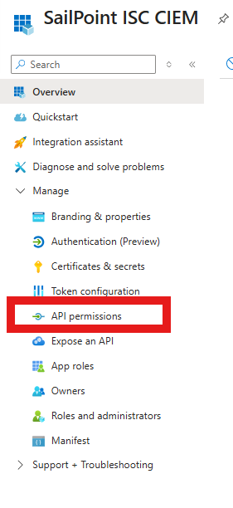
- Select Microsoft Graph.
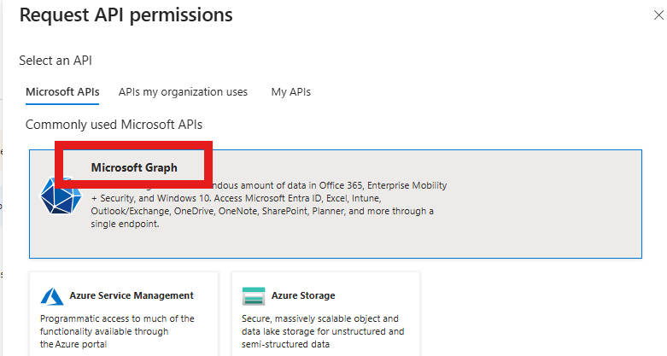
- Select Application permissions and expand the Directory category.
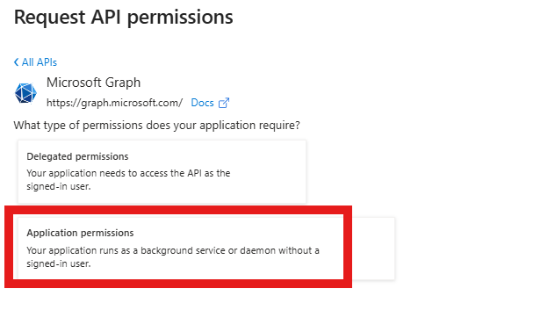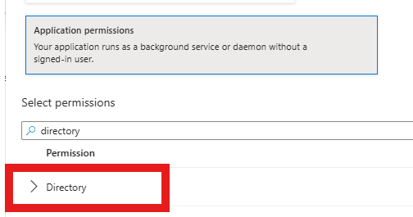
- Select Directory.Read.All to allow SailPoint CIEM to read directory data on your Microsoft Azure source.
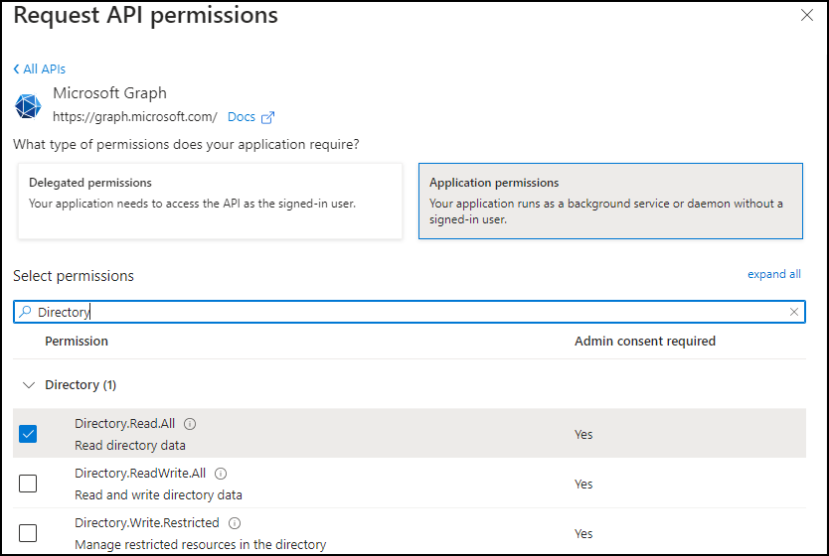
- Expand the Role Management category and Select RoleManagement.Read.Directory to allow SailPoint CIEM to read all directory role-based access control settings for the source.
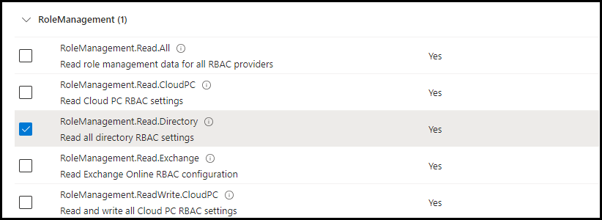
Optional:
- If you use Privileged Access Management (PIM) for groups, search for "privileged" in the Select permissions search bar. Select the following API permissions so SailPoint CIEM can include potential Azure cloud resource access derived from eligible membership in PIM groups:
- PrivilegedAccess.Read.AzureADGroup
- PrivilegedAssignmentSchedule.Read.AzureADGroup
- PrivilegedEligibilitySchedule.Read.AzureADGroup
- Select Add permissions and Grant admin consent to specify what the SailPoint app can request and to confirm the app is approved to make requests.
- Also click Grant Admin consent for default directory.
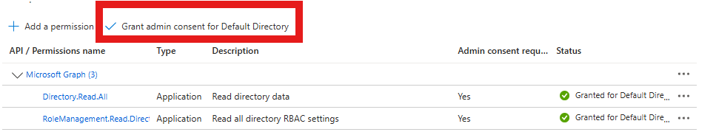

Creating Strict Custom Roles
Create custom roles in Microsoft Entra ID with the minimum permissions required to allow SailPoint CIEM to read your Microsoft Entra ID data.
- Search Management groups in Microsoft Entra ID.
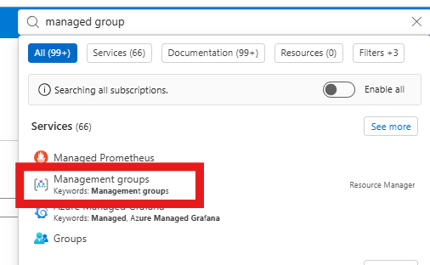
- Select the root management group to add the role to. The role will inherit the group’s subscriptions.
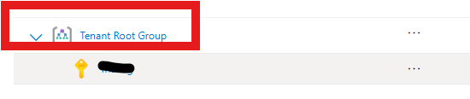
- In the sidebar, select Access control (IAM).
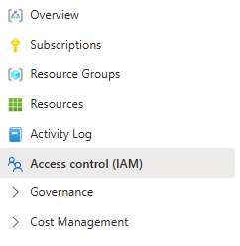
- Select Add and choose Add custom role from the dropdown menu.
- On the Basics tab, enter a custom role name, such as Resource Reader.
- Select the JSON tab.
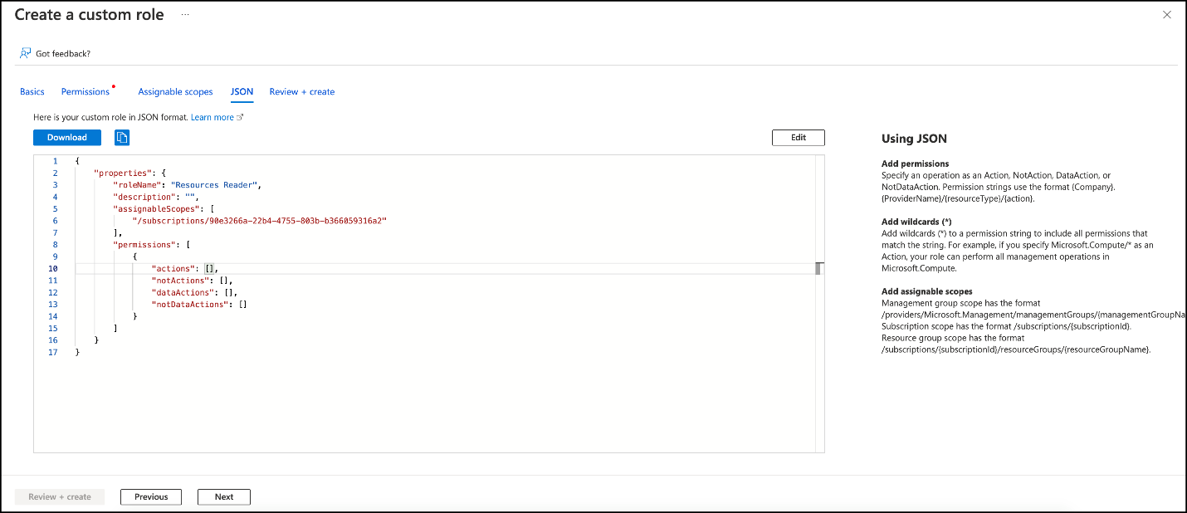
- Select the Edit button. Enter the below JSON schema, replacing the managementGroups ID with your own.

{
"properties": {
"roleName": "Resource Reader",
"description": "View strict list of resources, doesn't allow you to make any changes.",
"assignableScopes": [
"/providers/Microsoft.Management/managementGroups/aaaaaaa-9999-1234-5678-d1dd0000c000 "
],
"permissions": [
{
"actions": [
"Microsoft.ApiManagement/service/groups/users/read",
"Microsoft.ApiManagement/service/subscriptions/read",
"Microsoft.ApiManagement/service/users/groups/read",
"Microsoft.Authorization/*/read",
"Microsoft.Cache/redis/read",
"Microsoft.Compute/disks/read",
"Microsoft.Compute/virtualMachines/read",
"Microsoft.DBforMariaDB/servers/databases/read",
"Microsoft.DBforMySQL/servers/databases/read",
"Microsoft.DocumentDB/databaseAccounts/read",
"Microsoft.Insights/ActivityLogAlerts/Read",
"Microsoft.Insights/eventtypes/values/Read",
"Microsoft.Insights/LogProfiles/Read",
"Microsoft.KeyVault/vaults/keys/read",
"Microsoft.KeyVault/vaults/providers/Microsoft.Insights/diagnosticSettings/Read",
"Microsoft.KeyVault/vaults/read",
"Microsoft.KeyVault/vaults/secrets/read",
"Microsoft.ManagedIdentity/userAssignedIdentities/listAssociatedResources/action",
"Microsoft.ManagedIdentity/userAssignedIdentities/read",
"Microsoft.Network/loadBalancers/read",
"Microsoft.Network/networkInterfaces/read",
"Microsoft.Network/networkSecurityGroups/read",
"Microsoft.Network/networkWatchers/queryFlowLogStatus/action",
"Microsoft.Network/networkWatchers/read",
"Microsoft.Network/routeTables/read",
"Microsoft.Network/virtualNetworks/read",
"Microsoft.Network/virtualNetworks/subnets/read",
"Microsoft.Resources/subscriptions/resourceGroups/read",
"Microsoft.Resources/subscriptions/resources/read",
"Microsoft.Resources/tenants/read",
"Microsoft.Security/pricings/read",
"Microsoft.Security/securityContacts/read",
"Microsoft.Sql/managedInstances/administrators/read",
"Microsoft.Sql/managedInstances/databases/read",
"Microsoft.Sql/servers/administrators/read",
"Microsoft.Sql/servers/databases/auditingSettings/read",
"Microsoft.Sql/servers/databases/read",
"Microsoft.Sql/servers/databases/securityAlertPolicies/read",
"Microsoft.Sql/servers/failoverGroups/read",
"Microsoft.Sql/servers/firewallRules/read",
"Microsoft.Sql/servers/keys/read",
"Microsoft.Sql/servers/read",
"Microsoft.Storage/storageAccounts/blobServices/containers/read",
"Microsoft.Storage/storageAccounts/read",
"Microsoft.Web/sites/Read"
],
"notActions": [],
"dataActions": [],
"notDataActions": []
}
]
}
}

- Select Save to update the JSON schema and Review + create.
- Select Create to create the custom role.
You will now assign this role to the app.

Assigning Roles to App Registration
You must now assign the role you created to the App Registration.
- Search and Select Management groups in the Microsoft Entra ID portal.
- Select the root group name and select Access control (IAM) from the left sidebar.
- Select Add and choose Add role assignment from the dropdown menu.
- In the role section, Select the Type to Custom role and select the custom role you created earlier. Select Next.
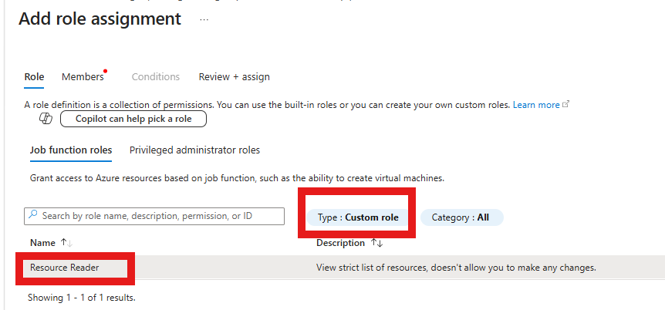
- In the Members tab, select the button next to User, group, or service principal.
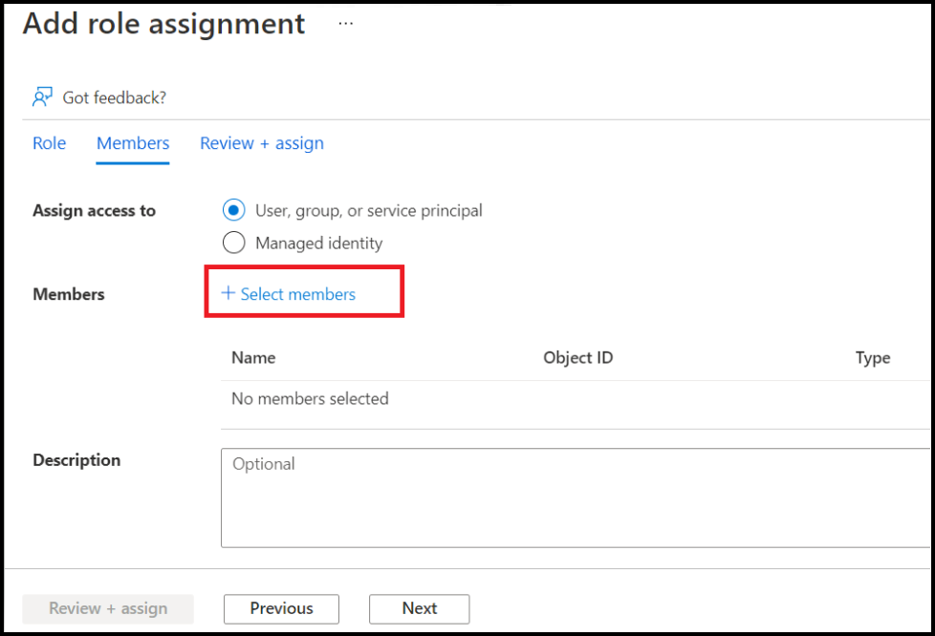
- Select Select members. Search for and select the application you registered.(SailPoint)
- Confirm your selection using the Select button (select User).
- Select Review + Assign to assign the role to SailPoint CIEM.

Creating a Client Secret for SailPoint CIEM
To finish registering your Microsoft Entra ID accounts, you'll need to create a client secret for SailPoint CIEM
- Select App registrations in Microsoft Entra ID and choose the application you named earlier.
- Select Certificates & secrets.
- Under Client secrets, select + New client secret and add a description and expiration date [Best Practice: Set an expiration date of 6 months.]
- Select Add.
- Save the Value and Secret ID in a safe place. You will enter the client secret in the Client Secret field when you connect to Identity Security Cloud.
Value: [REDACTED]
Secret ID: [REDACTED]

Creating Source in SailPoint
- Login to SailPoint ISC portal and Select Sources under Connection.
- Search for Microsoft Entra, click Actions.
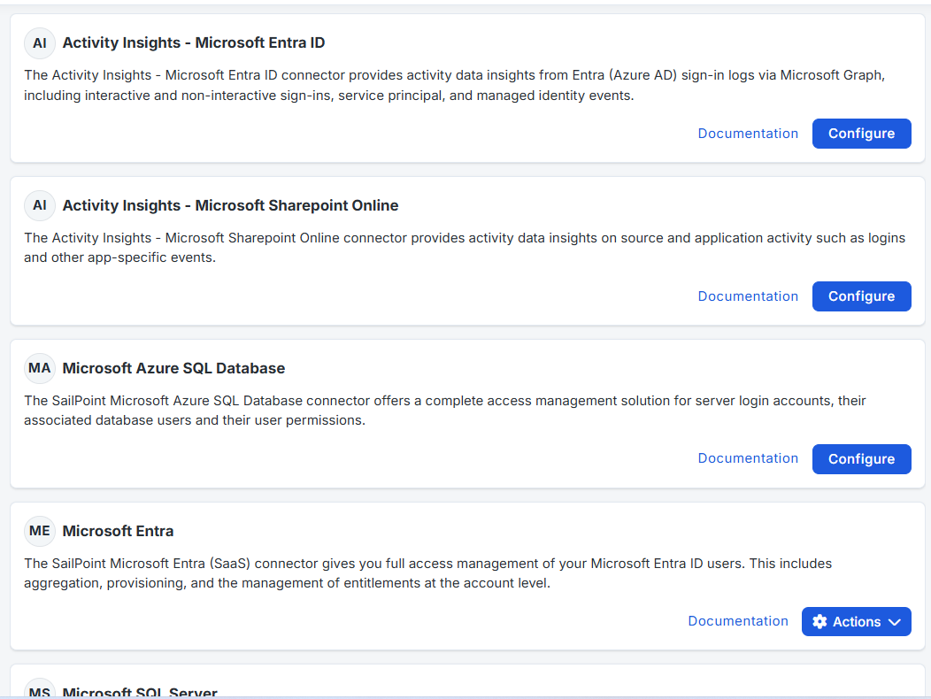
- Choose Standard Setup from the option
- Express Setup - Quick setup with fewer configuration choices/defaults(Simple/basic onboarding)
- Standard Setup- Full configuration — more control over connection, aggregation, provisioning, correlation, etc. (Real-world / lab learning)
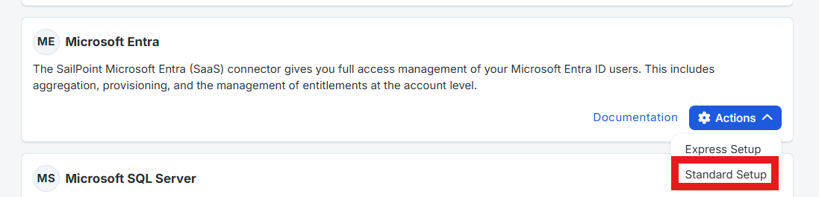
- Base Configuration:
- Source Name: Choice of you (Eg: Azure SaaS Connect)
- Source Description: Explain What action it is performing.
- Source Owner: Based on requirement & Choice
- Click Save.

- Connection Settings
- Grant Type: Select Client Credentials from drop down.
- Client ID:
- Client Secret:
- Domain Name: Give the Primary Domain from Entra ID.
- Feature Management
Leave all the options as default for now.

- Aggregation Settings and Filter Setting
Leave all option as default for now.

- Machine Identity Governance Settings
Keep all the option set to OFF and Click Save.
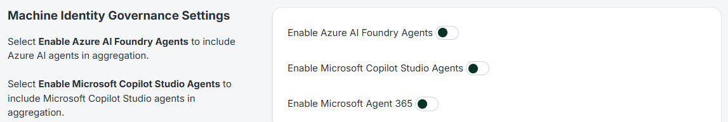
- Administrator Settings
No Change (keep default)
- Review and Test
Click Test Connection and wait for 1 to 2 minutes. Once you get the below pop up and click Continue Editing.
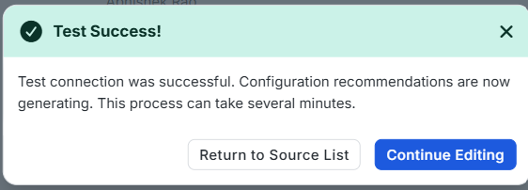
- Check Account Schema.
- Check Account Correlation
- Once both Account Schema and Account Correlation looks good click Account Aggregation and click Start Aggregation.
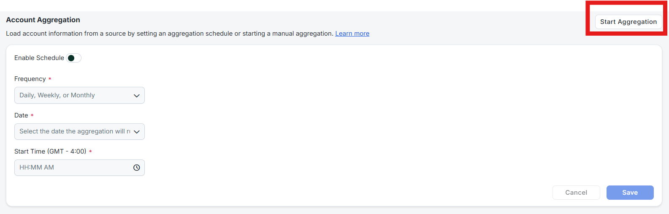
- Once Aggregation is completed you can see the status in Latest Account aggregation under Account Aggregation tab.
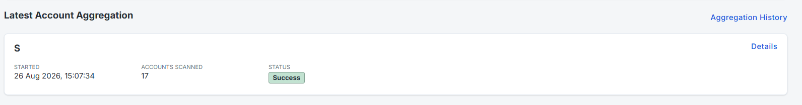

Connecting Azure and CIEM
Once you have configured your Microsoft Entra ID account, you can connect it to CIEM using a SaaS connector or VA-based connector:
- SaaS-based connector (recommended)
- VA-based connector and the CIEM Azure connector
When you have completed the steps for your connection type, aggregate and mark the entitlement types that grant cloud access. You can then view the effective access those entitlements grant on aggregated Azure cloud resources and include cloud entitlements in certification campaigns.
Using the Microsoft Entra ID SaaS Connector
If you are using Microsoft Entra SaaS, follow the connector guide to enable SailPoint CIEM.
After a successful test connection, you can optionally set the source scope before aggregating accounts and marking the entitlement types that grant cloud access.
Setting Source Scope for SaaS-Based Connections
By default, SailPoint CIEM reads and automatically discovers changes to your cloud infrastructure. You can choose to exclude scopes to prevent SailPoint CIEM from including data for those accounts.
When you exclude scopes, SailPoint CIEM will only read and include data from selected scopes. When Auto-Include Scopes is disabled, new and deleted subscriptions in your cloud system will be detected, but SailPoint CIEM will not automatically include data from new scopes until you select the subscriptions individually or reenable Auto-Include Scopes.
You can use the CIEM event triggers in workflows to be notified about scope changes.
To change the scope of your included source data when using a SaaS-based connector:
- In the Microsoft Entra ID SaaS source, select Cloud Scopes under Additional Settings.
- Select which cloud scopes to include:
  - To automatically include data from all subscriptions, enable Auto-Include Scopes. Deselecting a scope disables Auto-Include Scopes.
  - To include a subset of subscriptions, use the checkboxes to change which scopes are included

